

**NAME** :  *KASHIF MAJID DAR*

**BRANCH**:  *CS B-1*

**BATCH**: *2019-23*

**PRN:**  *19070122084*

**Programming and Problem Solving Lab**

**Assignment 4**

1. Write a Python program for Roots of a quadratic equation?

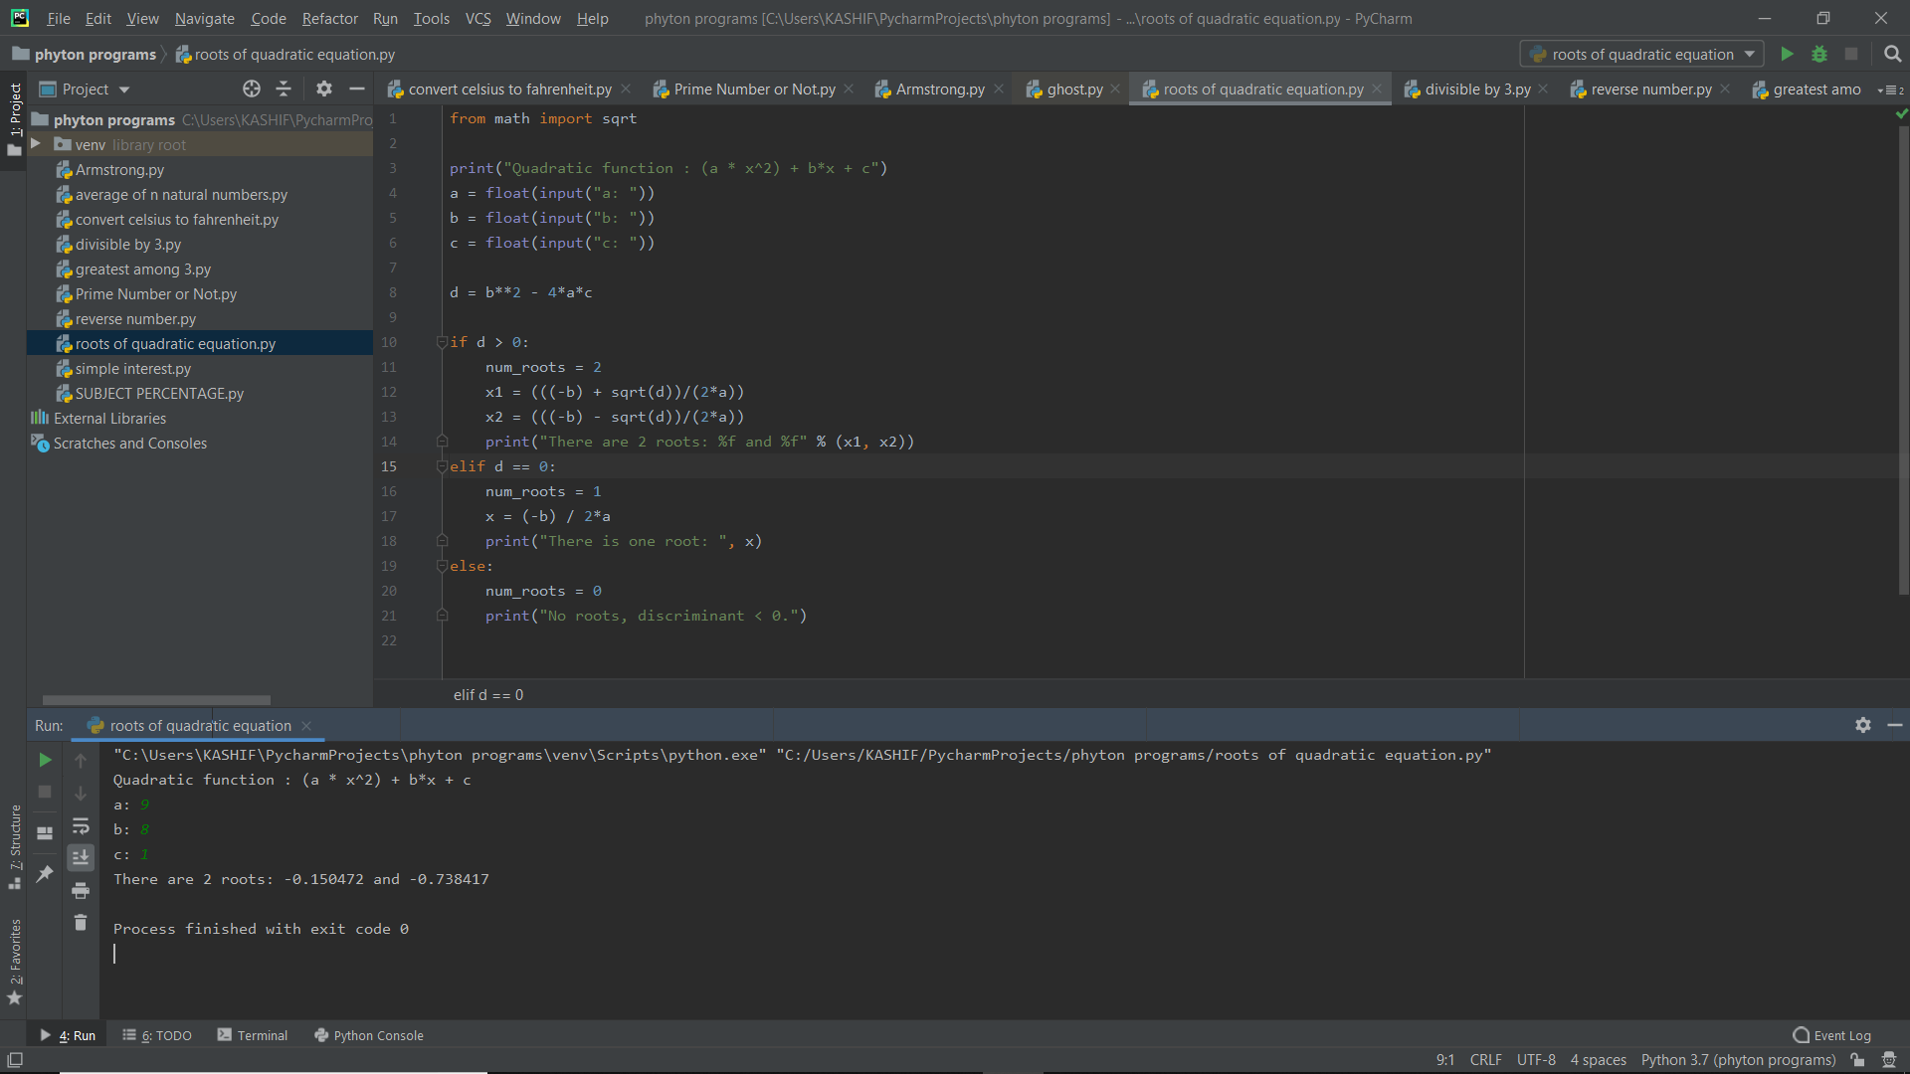

1. Divisible by 3 between the user-defined range a to b?

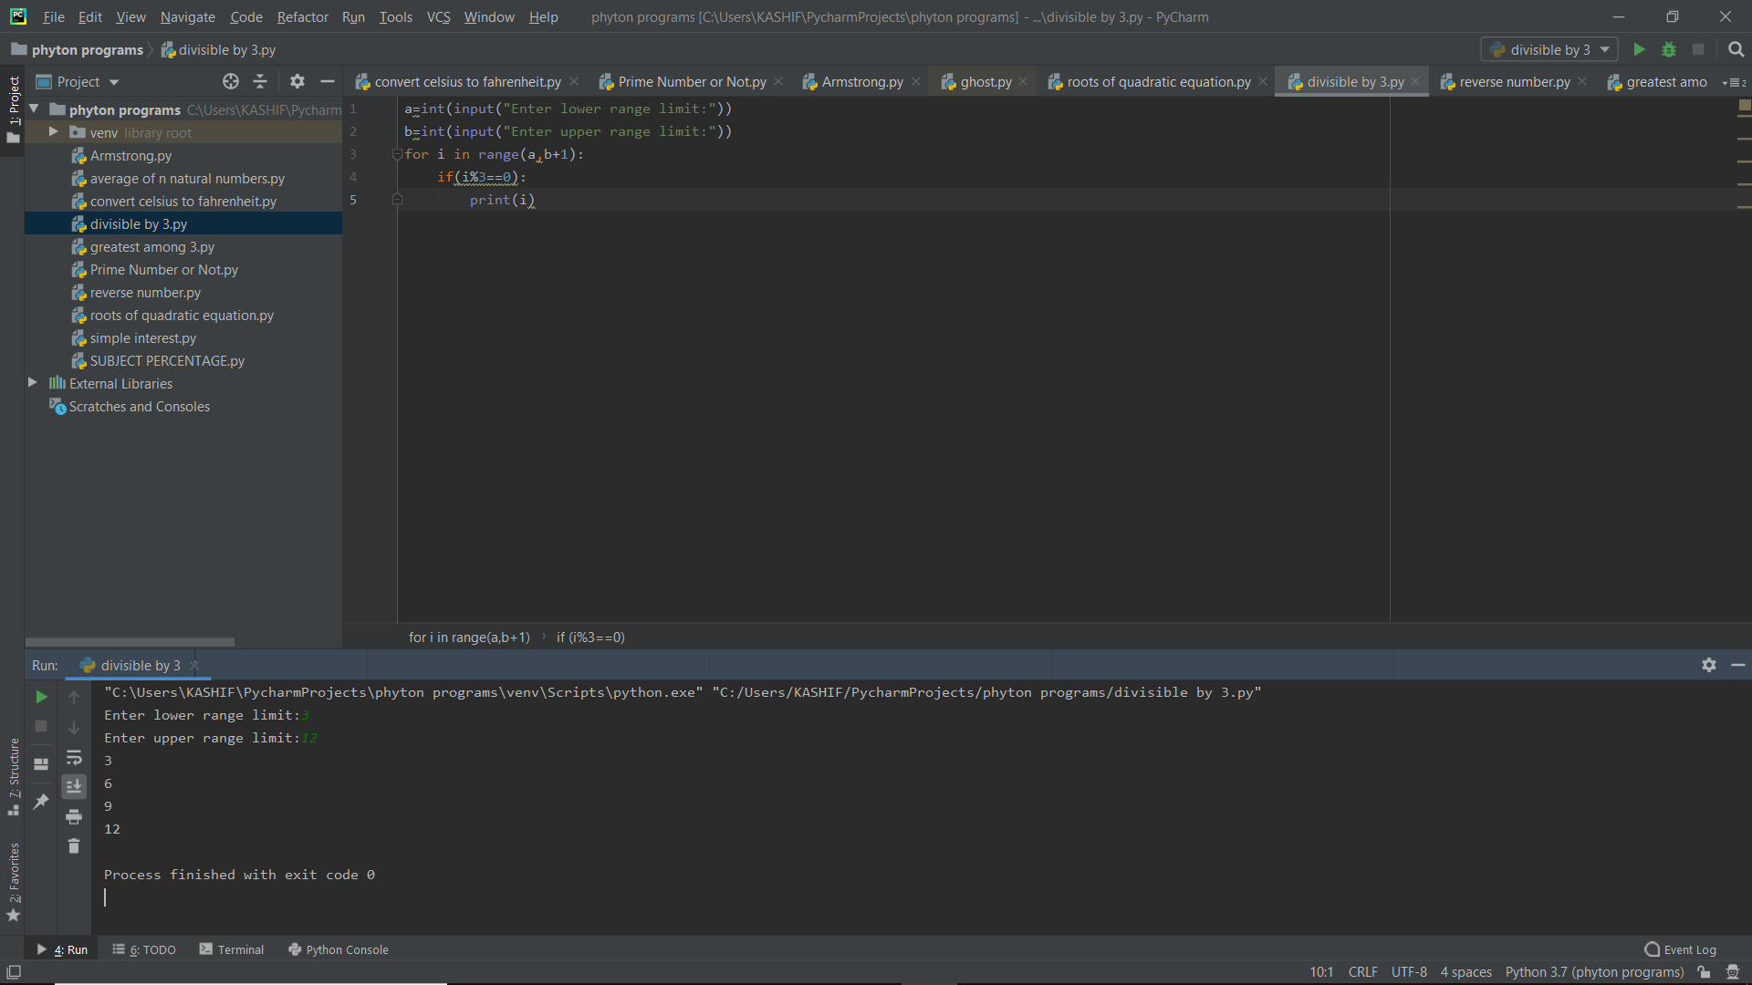

1. Write a program to reverse a number provided by user?

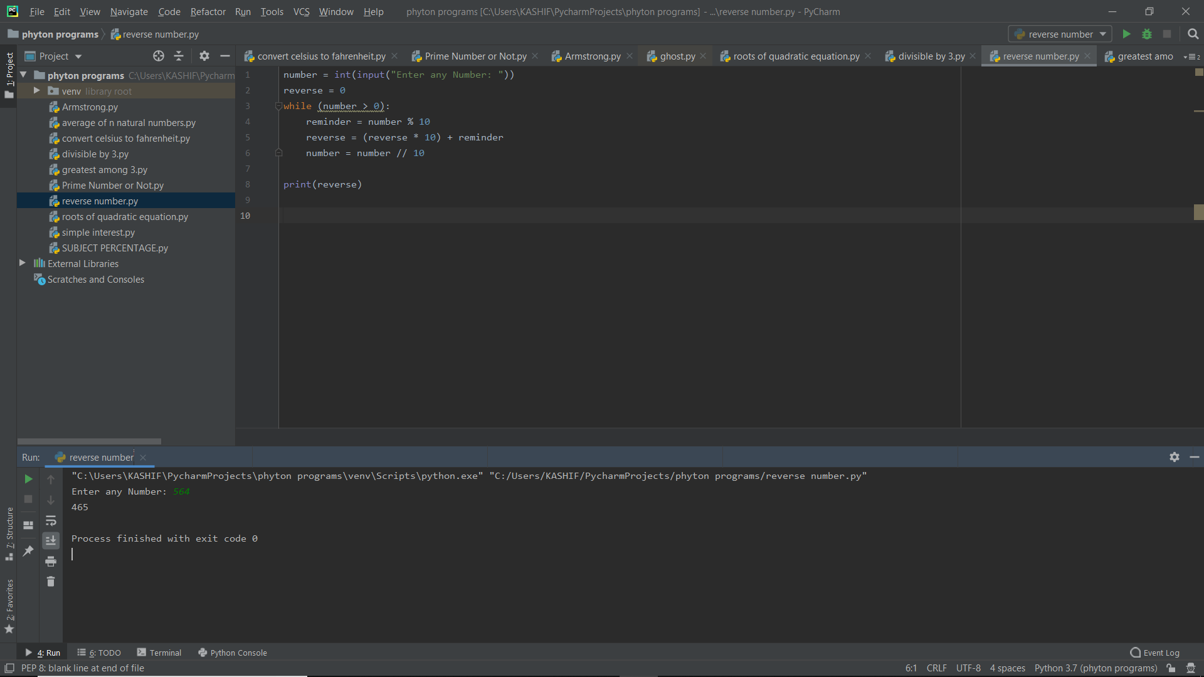

1. Write a program which follows the below trend:

 123 -> three two one

